SIFT Codage

We used the sift.detectAndcompute() function of Opencv in python which is composed by sift.detect() for find the key-points and sift.compute() for calculate the descriptors from the key-points. We added some options to allow the program to scan whole the database, calculate the sift descriptors of each image and save them on a txt file.

SIFT test

In this stage, the goal is to apply different transformation on an image. Then calculate the descriptors on each image by using the SIFT algorithm in order to check the invariance of the SIFT descriptor to the rotation, luminosity and the scale changes.

On the following images, we can see the results obtained.

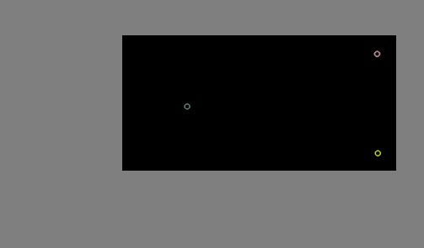

Figure 1 Key-points detected on the original image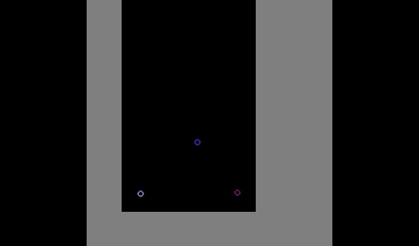

Figure 2 key-points detected on the image after rotation

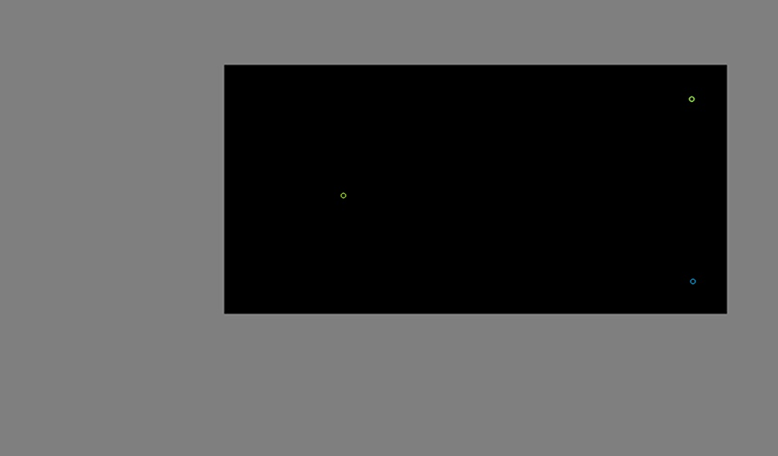

Figure 3 Key-point detected after scale change

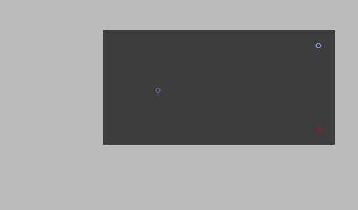

Figure 4 Key-points detected after luminosity change

The results show that whatever the transformation we have same number of key-points but they are in different positions according to the transformation.

We can confirm that the the sift descriptor is invariance to the rotation, the luminosity and the scale changes.